

**FACULTY OF ENGINEERING AND NATURAL SCIENCES**

**ENS 209**

**INTRODUCTION TO COMPUTER-AIDED DRAFTING & SOLID MODELING**

**TERM PROJECT FINAL REPORT**

**“WIND-UP TOY CAR”**

Prepared by:

Ufuk Ulaş Tokat 28914

Okan Arslantaş 26345

Çise Göksu Uzun 28502

Begüm Boynukısa 27052

Supervised by:

Utku Seven

**Product Description:**

The wind-up toy car is an automaton toy car powered by a clockwork engine (Wulffson, 2022.) Automata produced for art, entertainment, and simulation have been seen, with examples including the Heron of Alexandria creating clockwork birds during the Hellenistic Period. It is commonly said that Leonardo da Vinci invented the mechanical lion that he gave to King Francois I in France in the 16th century. The Château du Clos Lucé has a replica of this mechanism even if the original drawings are lost to time (Shirbon, 2009).

They work by storing the movement of the rotating wheels as energy in a helical spring inside the large central-toothed wheel after the car is pulled back while being pushed down. When released, it will unwind and move the car ahead. A clutch disengages once the spring has completely sprung, allowing the machine to roll free (Sorrel, 2011).

Wind-up toy car designs are generally formed by a body, 4 tires, and at least one wind-up motor that includes a gearbox that has a minimum of 5 different gears, 2 main shafts, 1 medium shaft, coiled spring, and cosmetic parts for the aesthetic.

The wind-up toy design in this project has 12 unique parts. These are 2 bodies (upper and lower body), 5 gears, 3 motor parts, 1 coiled spring, and 1 wheel.

Polylactic acid (PLA) will be used as a material except for wheels, which were typically made of fiber cords that were woven together and coated in rubber. Whereas for 3D printing, all parts will be produced by PLA.

Since wind-up toy cars are a particular type of product, there isn’t any publicly available market research. Due to that, broader market research was conducted. This market research includes the global toy and toy car markets.

According to Roshan D. (2022), the toy car market is segmented into types, applications, and regions. Types include metal, plastic, and others; applications are segmented as family and kindergarten; region covers North America, Europe, Asia-pacific, and LAMEA. Key market players are highlighted as Hasbro, Amalgam, Mattel, Lego, Bandai, and Looksmart.

D. Tighe (2021), shows that retail sales of toy vehicles in the United States are nearly 1.55 billion U.S. dollars in 2020 and 1.34 billion in 2019, 1.46 billion in 2018, and 1.56 billion in 2017.

A study on the competitiveness of the toy industry (2013) anticipated that sales of traditional games and toys will exceed 1 billion euros in Europe, 0.9 billion euro in the US, and 0.5 billion euro in china. In 2011 sales of car and construction toys had a 12% market share in Europe, %9 in the US, and %13 in China, and they are demanded mostly by the 0-14 age group. The main players in the toy market are Mattel, Lego, Hasbro, Private Label, Simbia-Dickie group, and Vtech Holding.

**Dissection of the product:**

The wind-up toy design in this project has 13 unique parts. These are 2 bodies (upper and lower body), 5 gears, 3 motor parts,1 shaft, 1 coiled spring, and 1 wheel.

The upper body is used for aesthetic reasons and it covers the motors, gears, and coiled spring. The lower body was used for shafts, which were connected wheels with motors.

Gears are used inside the motors and they transfer the energy in two ways: first (as the car is moved backward by the user) from wheels and shafts to a coiled spring; second (when energy is stored inside the coiled spring due to backward motion) from coiled springs to shafts and wheels.

3 different motor parts are used to create a single big motor. These motors consist of a coiled spring and five gears. With motors and parts inside them, they shape the gearbox.

The coiled spring functions as energy storage and is responsible for the movement of the toy car. As someone pulls the car backward, the motion of the turning wheels is stored as energy inside the coiled spring. Then letting go of the car disengages the spring and energy stored inside the spring go back to the wheels via gears and shafts.

Wheels served as a means between the car and the ground. It transforms the engine’s ( in this case gearbox) power into turning motion and creates movement. Wheels connected by shafts

We divide them into three groups for assembly: the main body assembly, gearbox assembly, and wheel assembly. For assembly relationships, we have a total of 42 mates between different parts of the product. To give an example, we add 15 mates to the project report. The rest of them are shown in the solid assembly file.

First, gearbox assembly will be conducted. It is the most complex part of the product. Five gears assembled to each other and coiled spring. Then they assembled motor 2. When motors 1 and 3 are assembled into these parts, the gearbox will be shaped. The gearbox was assembled to the shaft to make the connection between wheels, gears, and coiled spring. This assembled shaft part is added to the lower body of the wind-up toy car. Then the upper body was assembled to cover up the gearbox. Lastly, wheels were added to the shaft and front part of the lower body.

Assembly drawing will shown as:

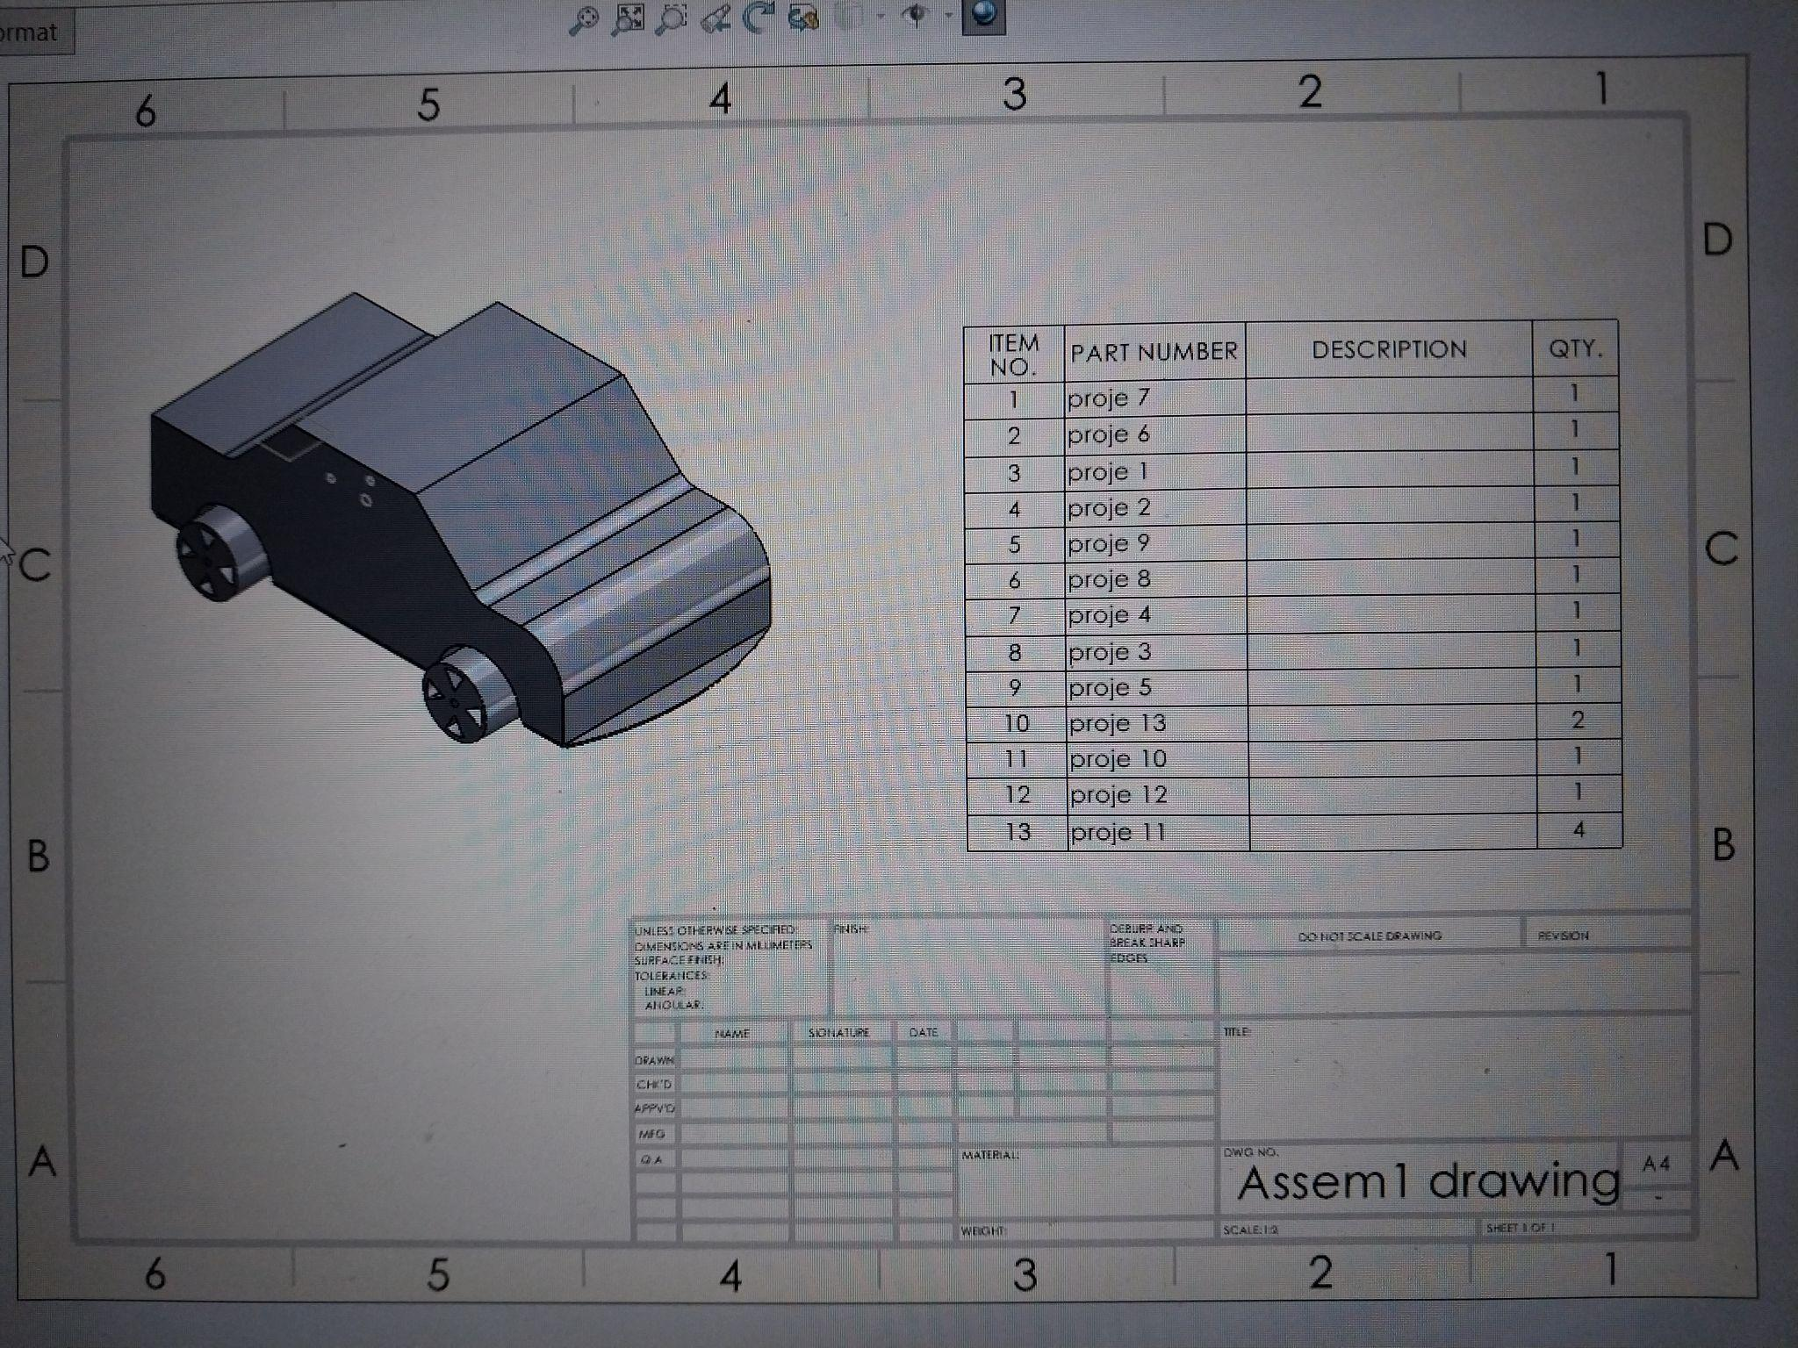

Pictures of dissection and 15 example mates are shown here:

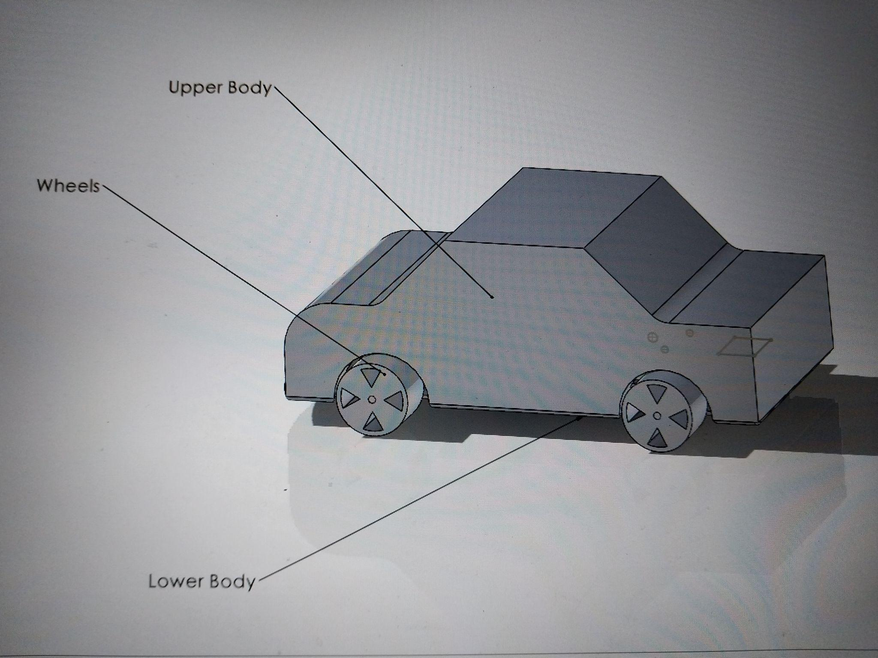

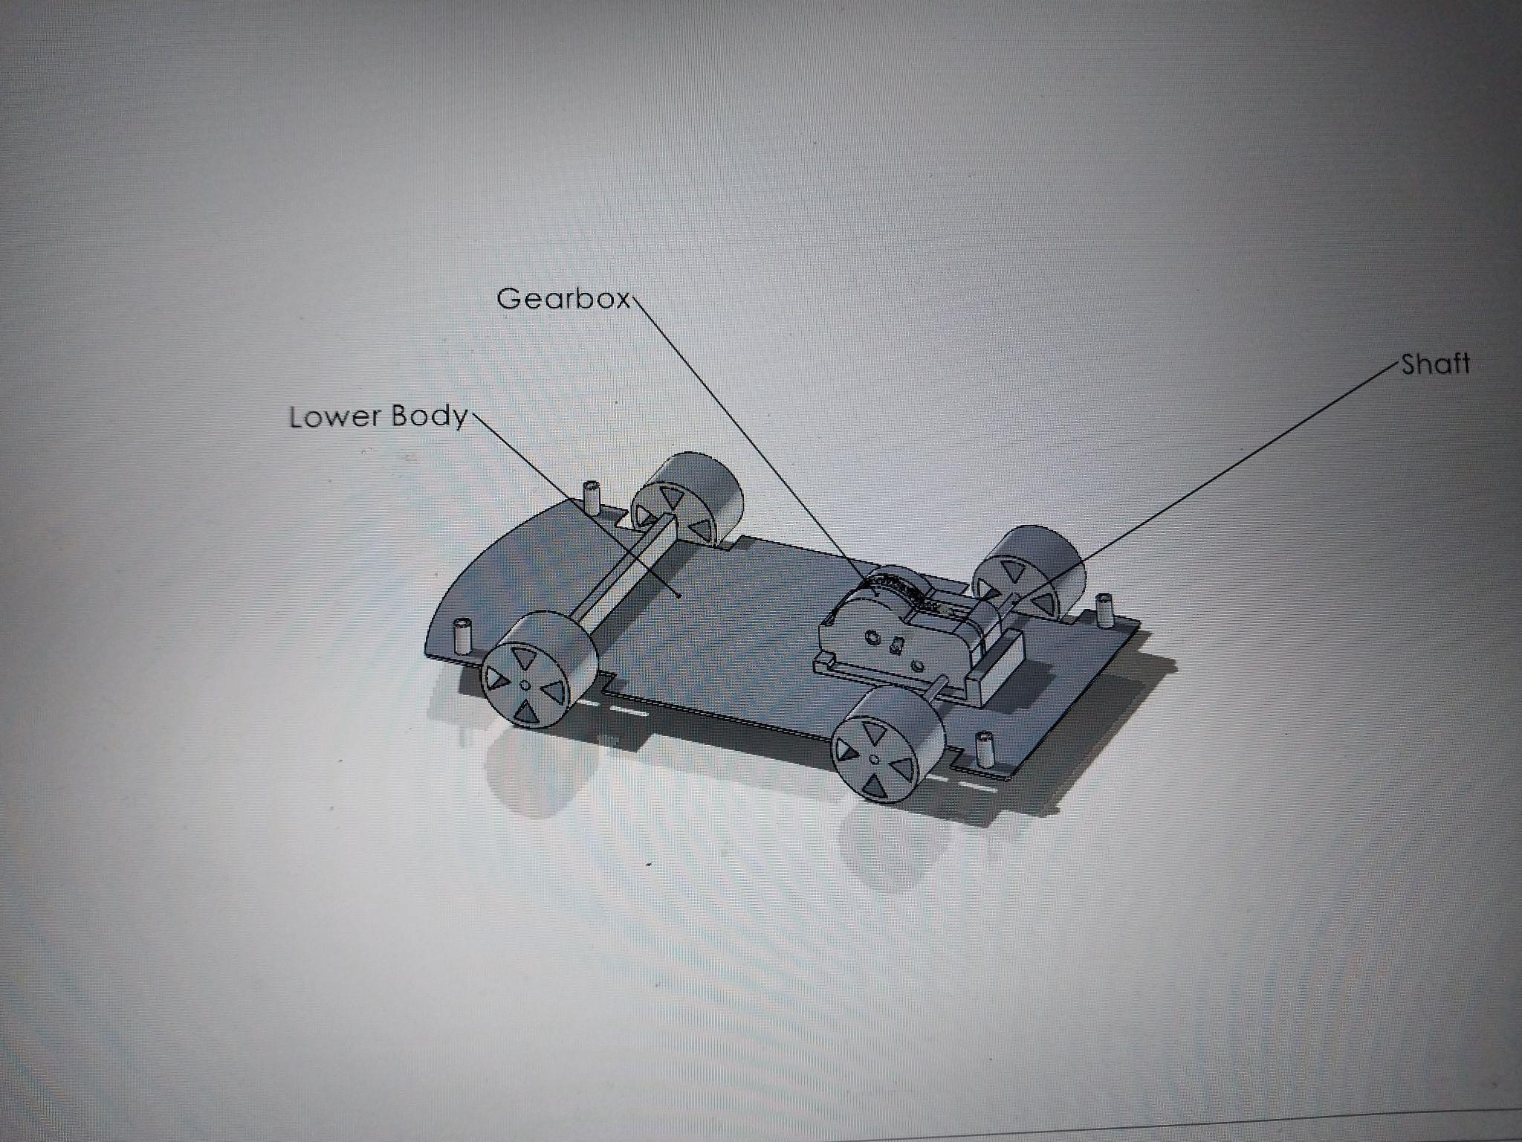

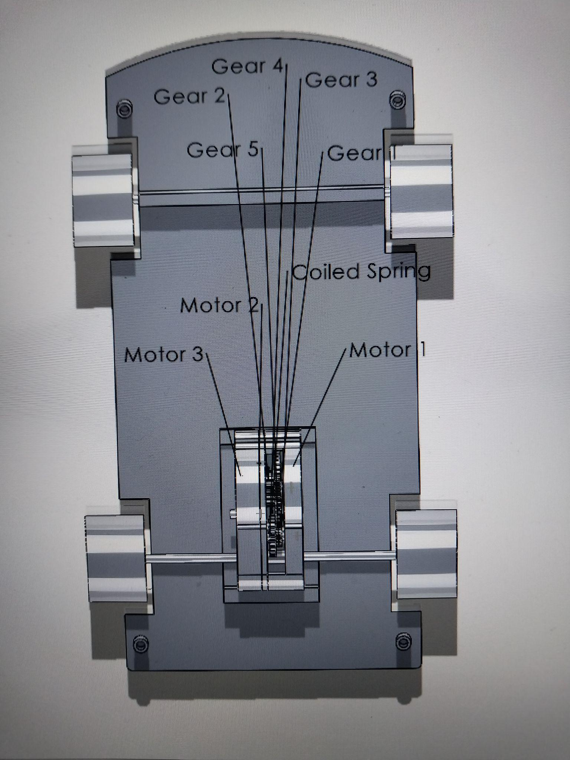

Example Mates:

1) Concentric mate between motor 1 and coiled spring: Left upper hole of motor 1 is concentric with the center circle of the coiled spring.

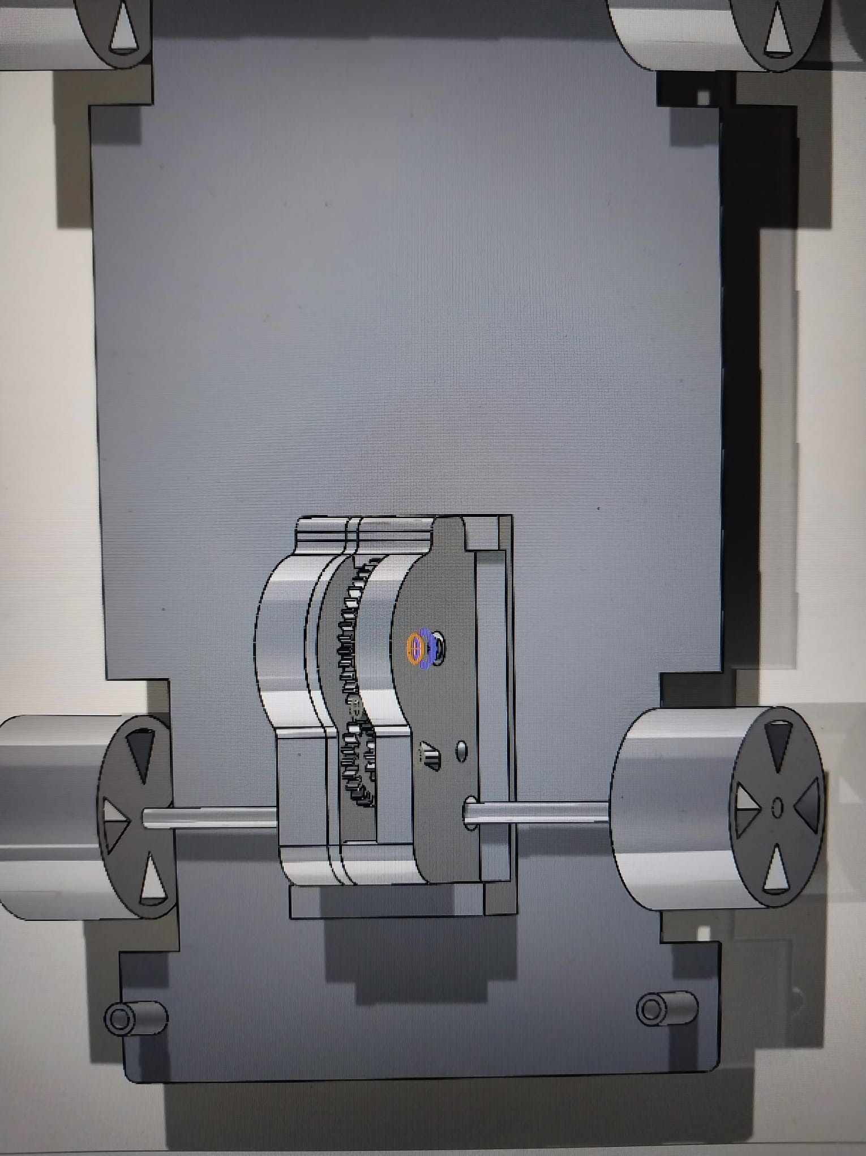

2) Coincident mate between motor 1 and coiled spring: The left face of motor 1 coincides with the face of the coiled spring.

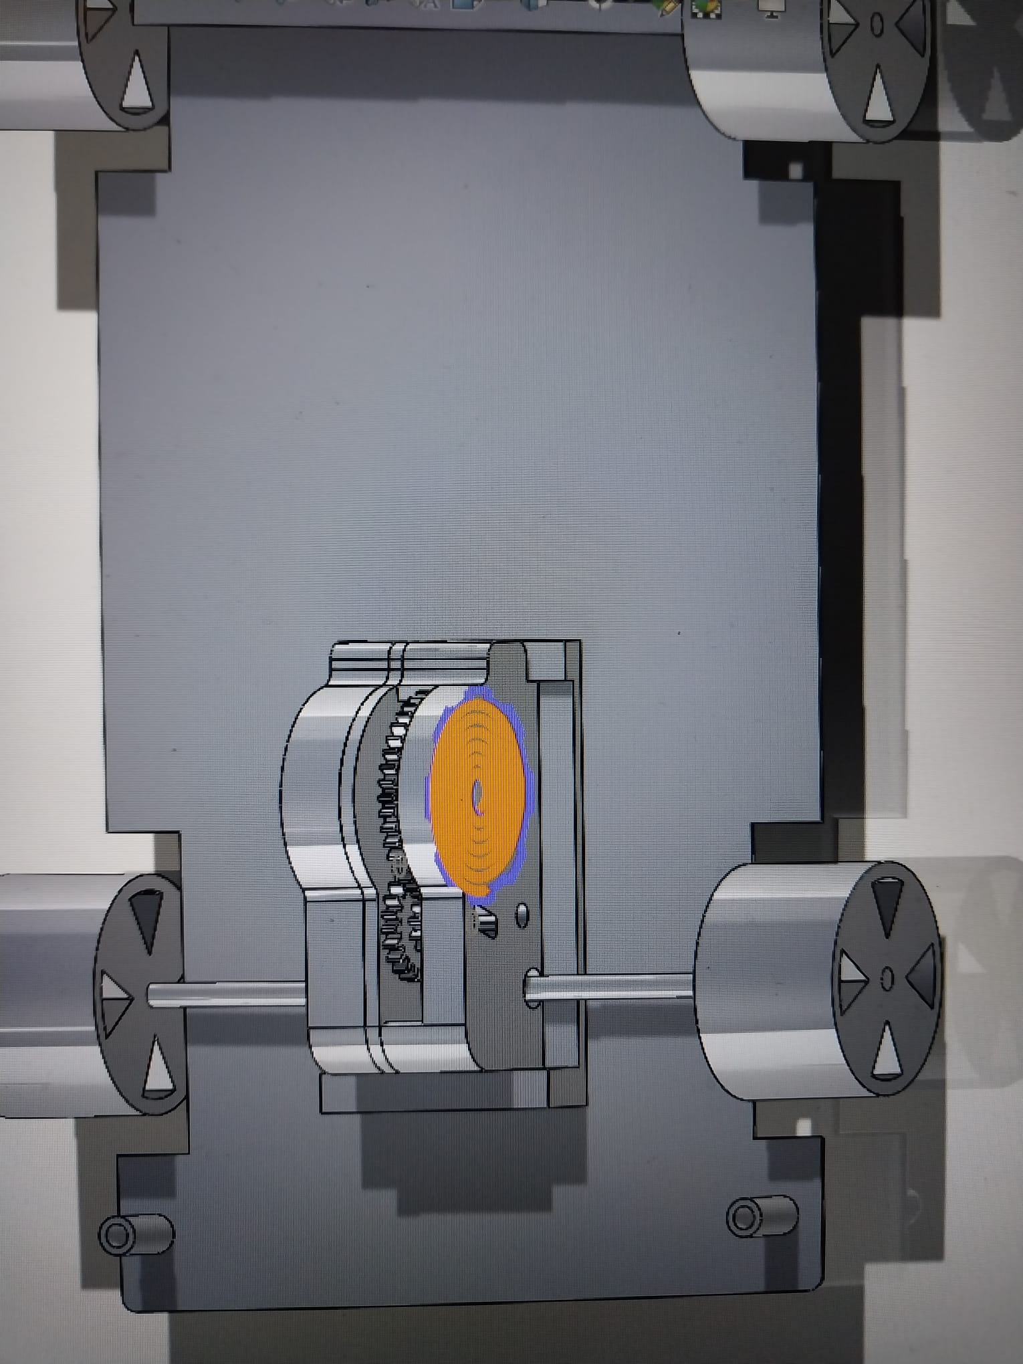

3) Concentric mate between motor 1 and gear 1: Left upper hole of motor 1 is concentric with the cylinder the gear 1.

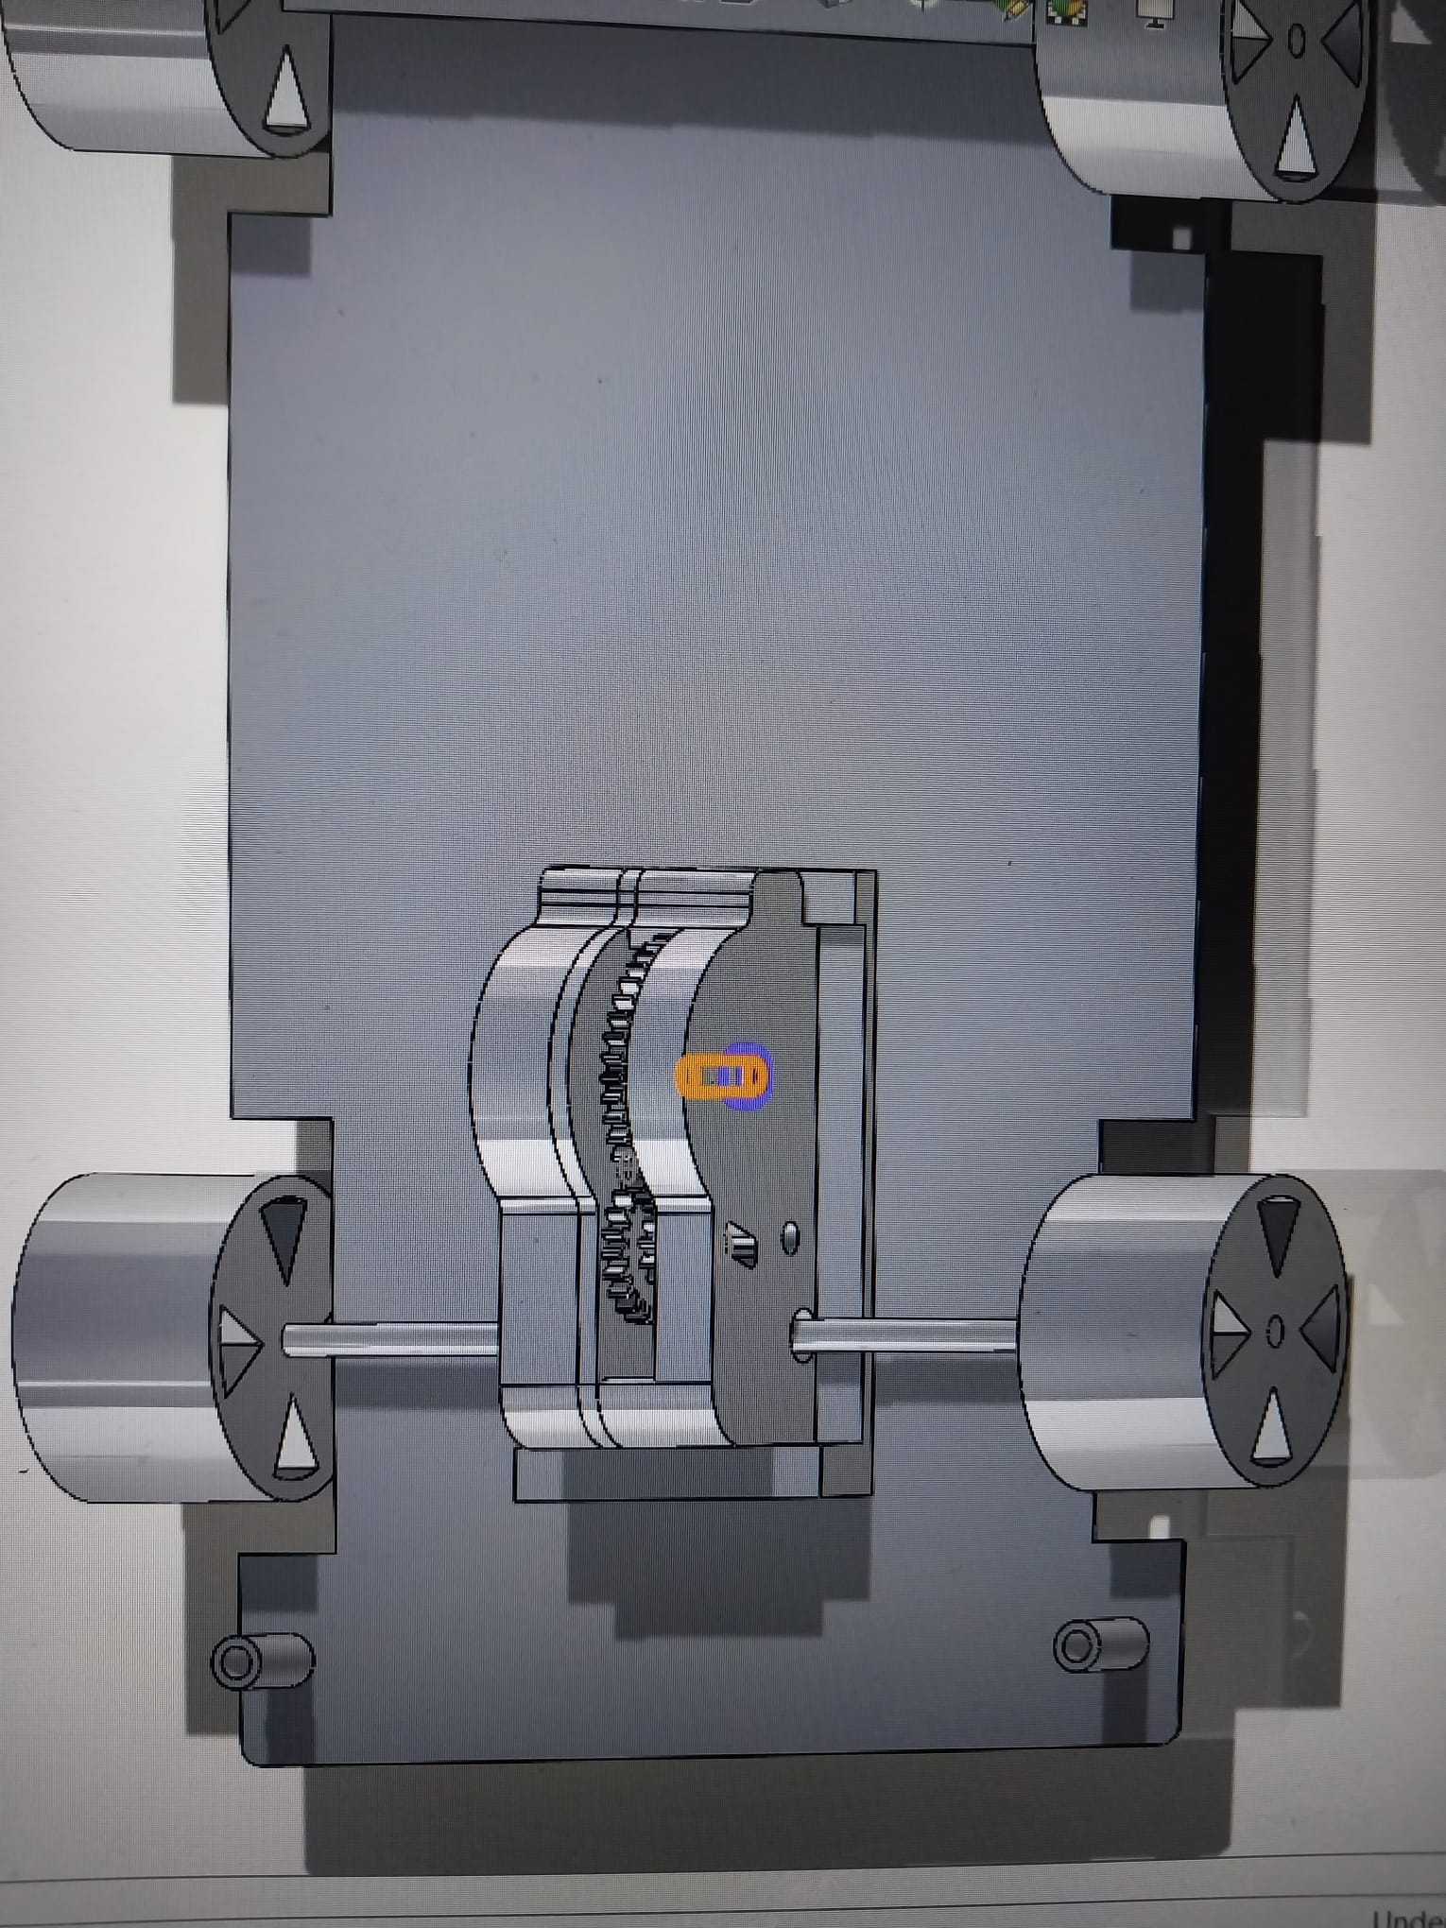

4) Coincide mate between motor 1 and gear 1: Left upper hole of motor 1 coincides with the outer piecewise cylinder of gear 1.

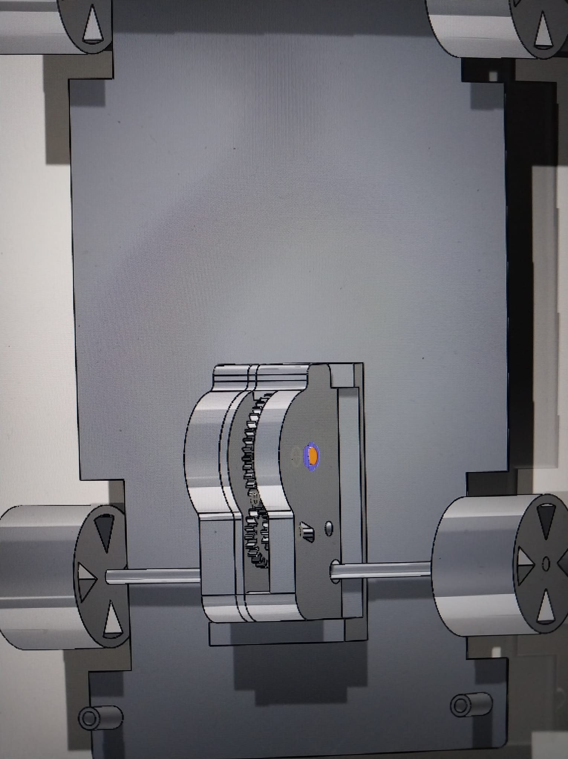

5) Parallel mate between gear 1 and coiled spring: Upper part of gear 1 is parallel with the center part of the coiled spring.

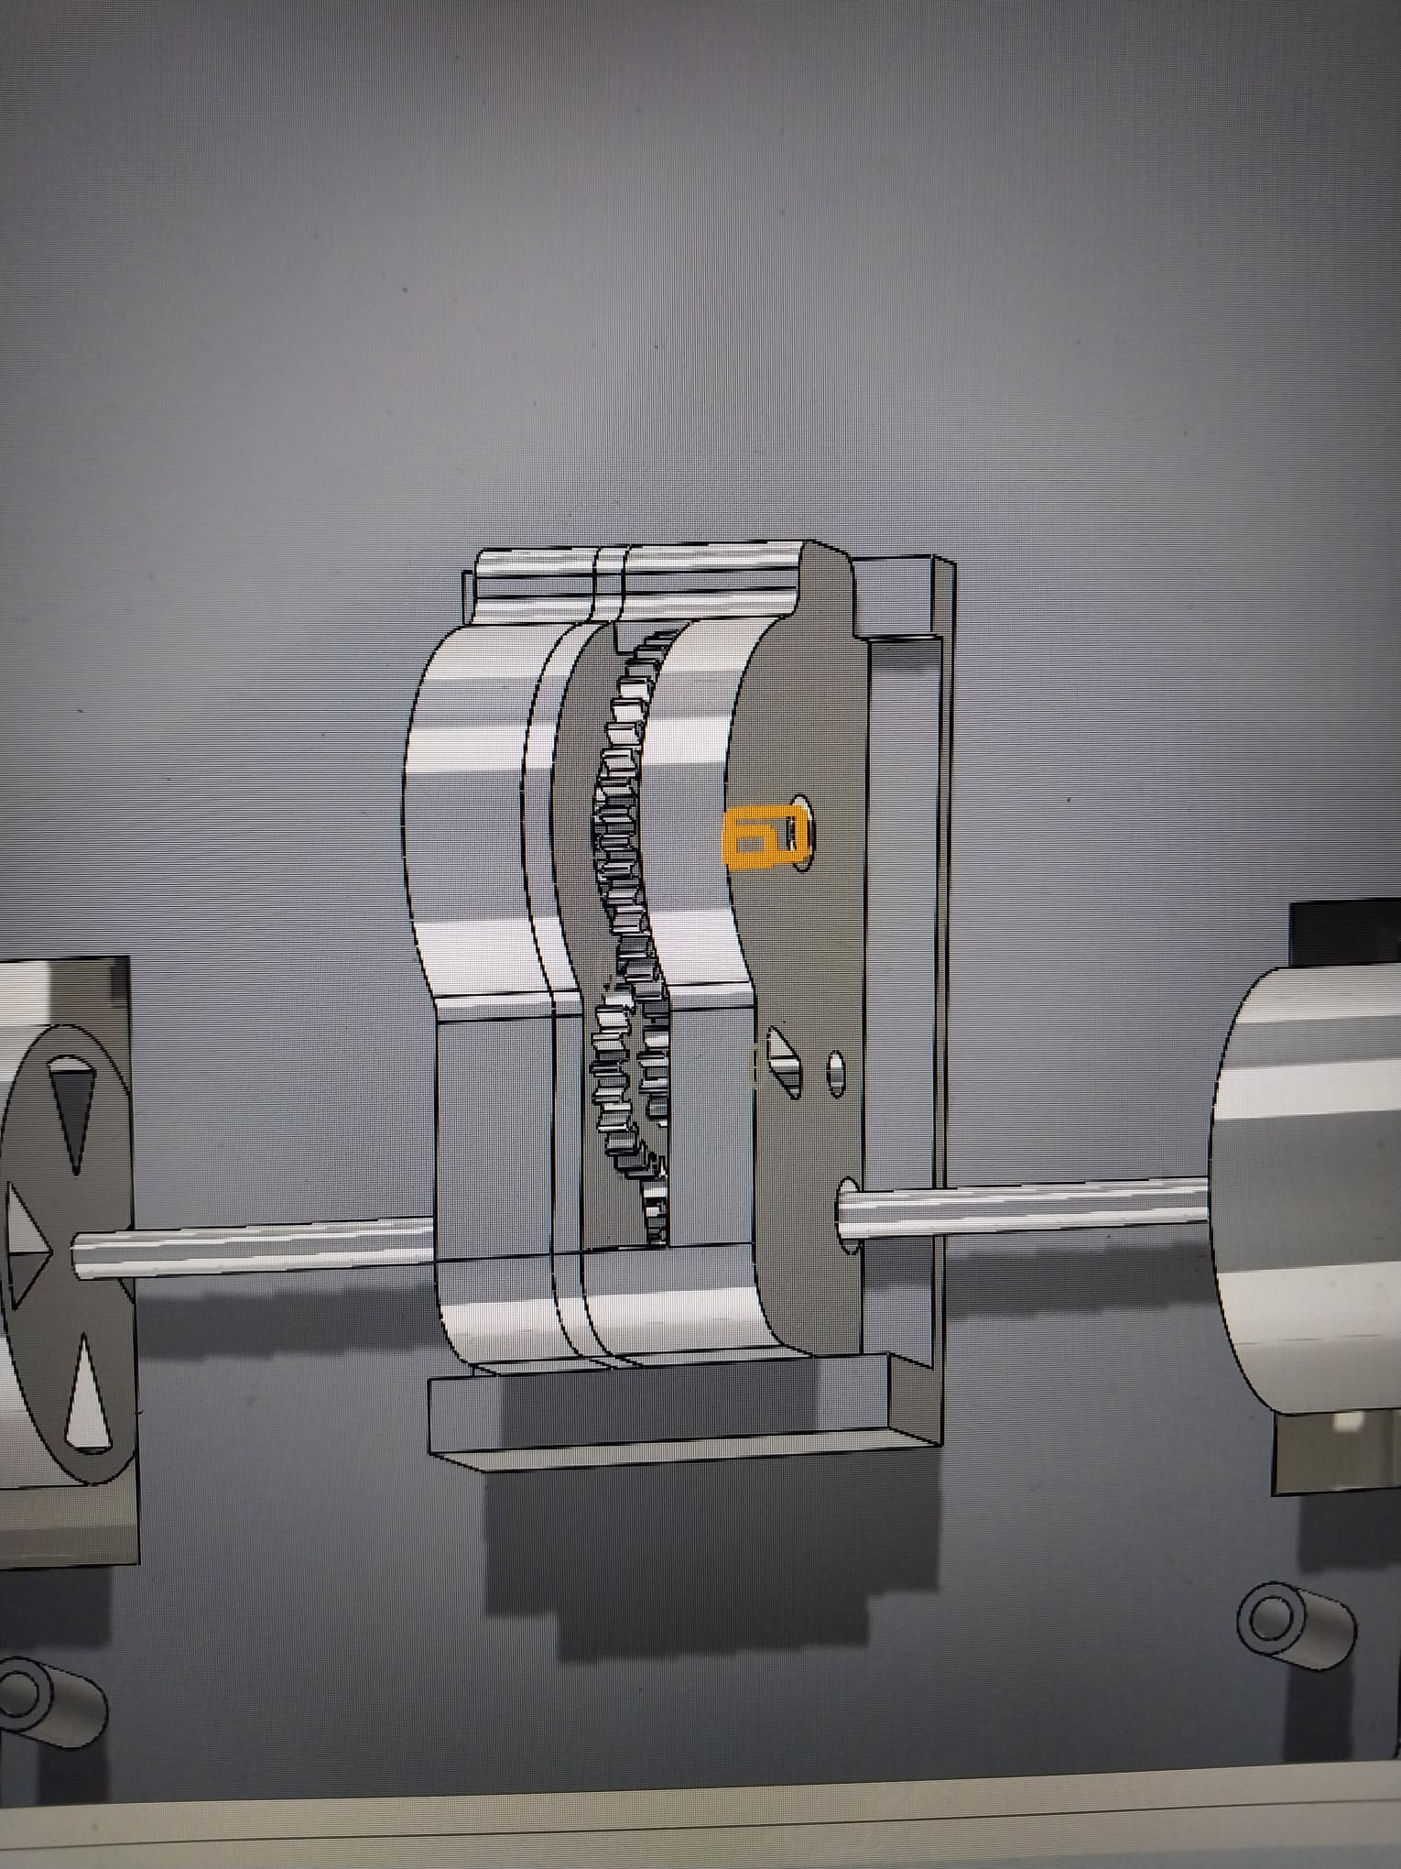

6) Concentric mate between motor 1 and gear 2: right upper hole of motor 1 is concentric with the outer cylinder of gear 2.

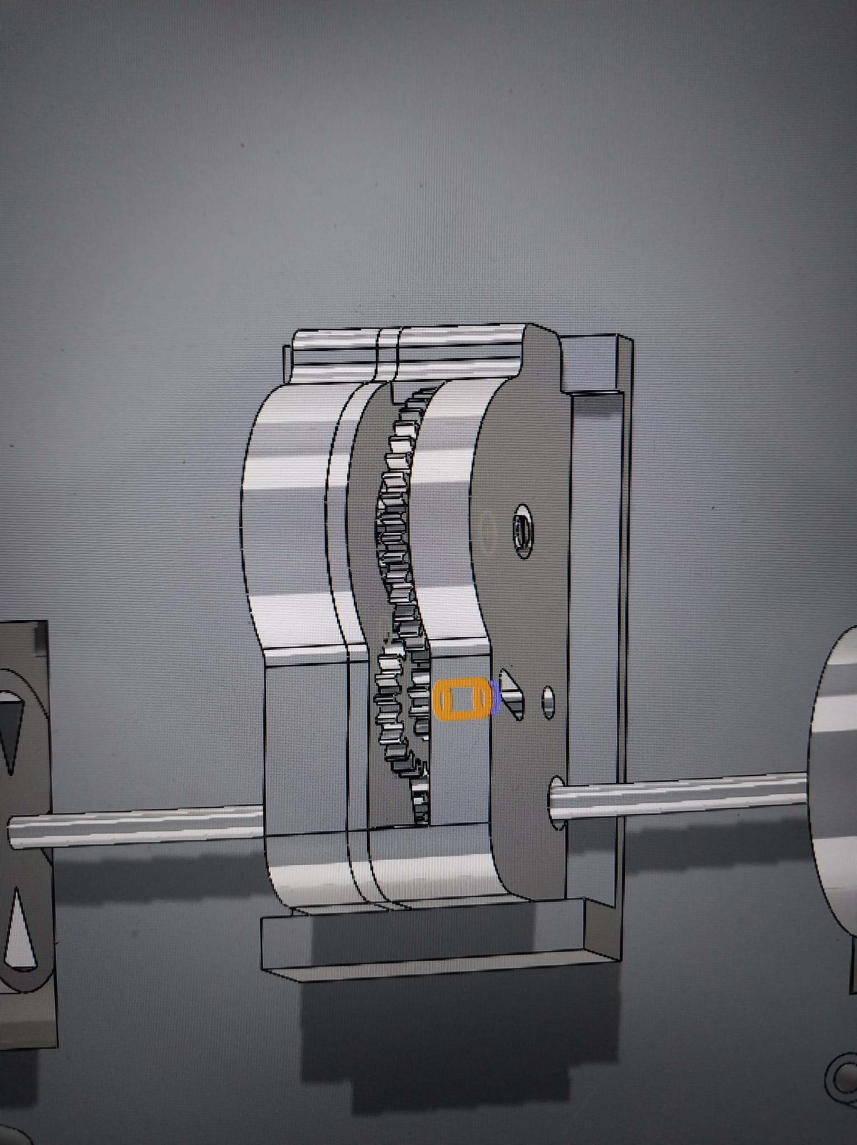

7) Coincide mate between gear 1 and gear 2: the face of gear 1 coincides with the face of gear 2.

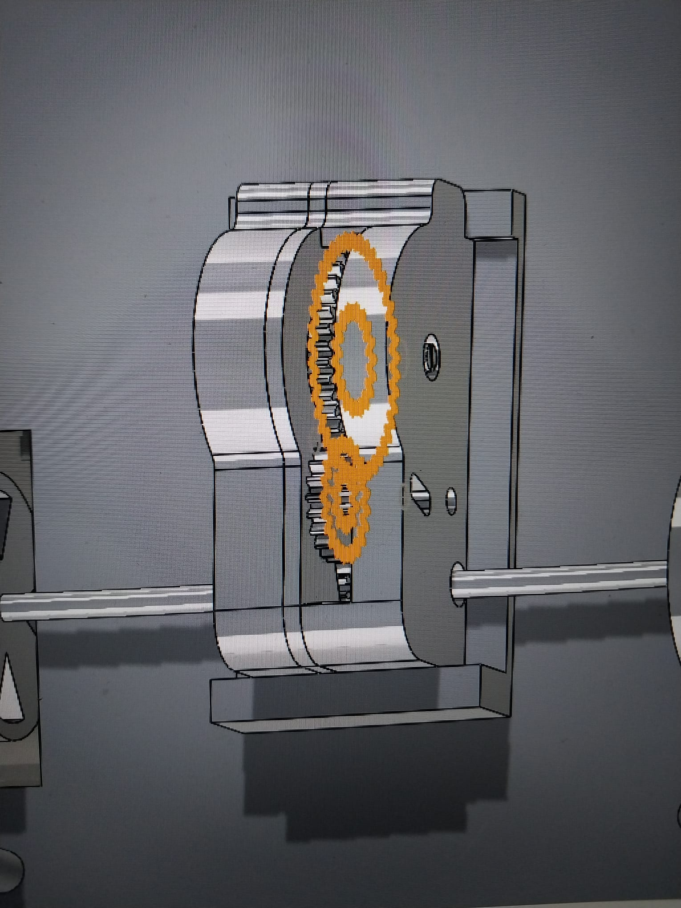

8) Gear mate between gear 1 and gear 2: the front cylinder of gear 1 gear mates with the front cylinder of gear 2.

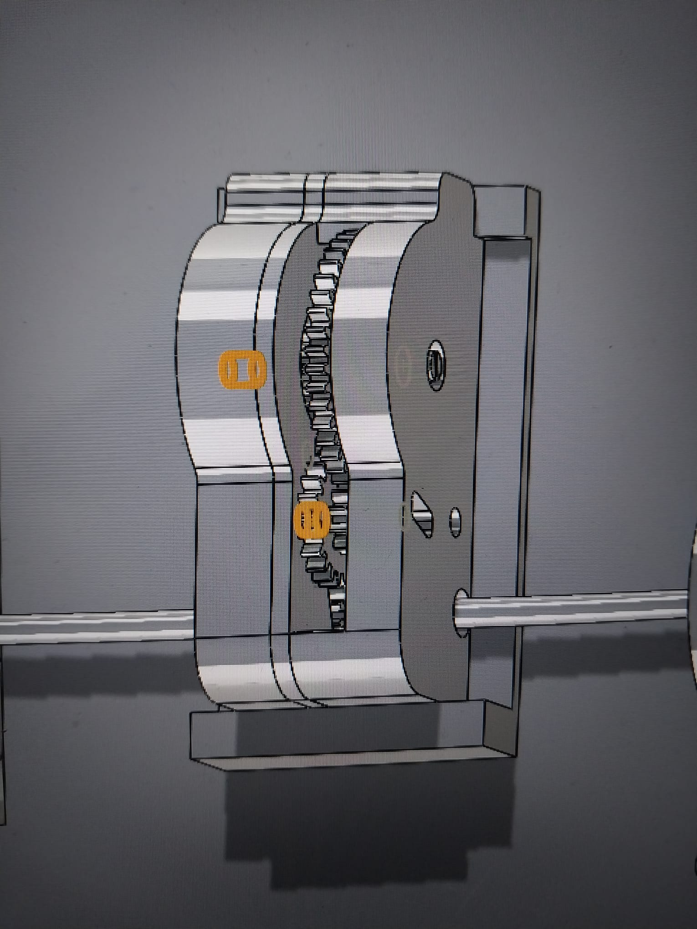

9) Concentric mate between motor 1 and motor 2: the right upper hole of motor 1 is concentric with the right upper hole of motor 2.

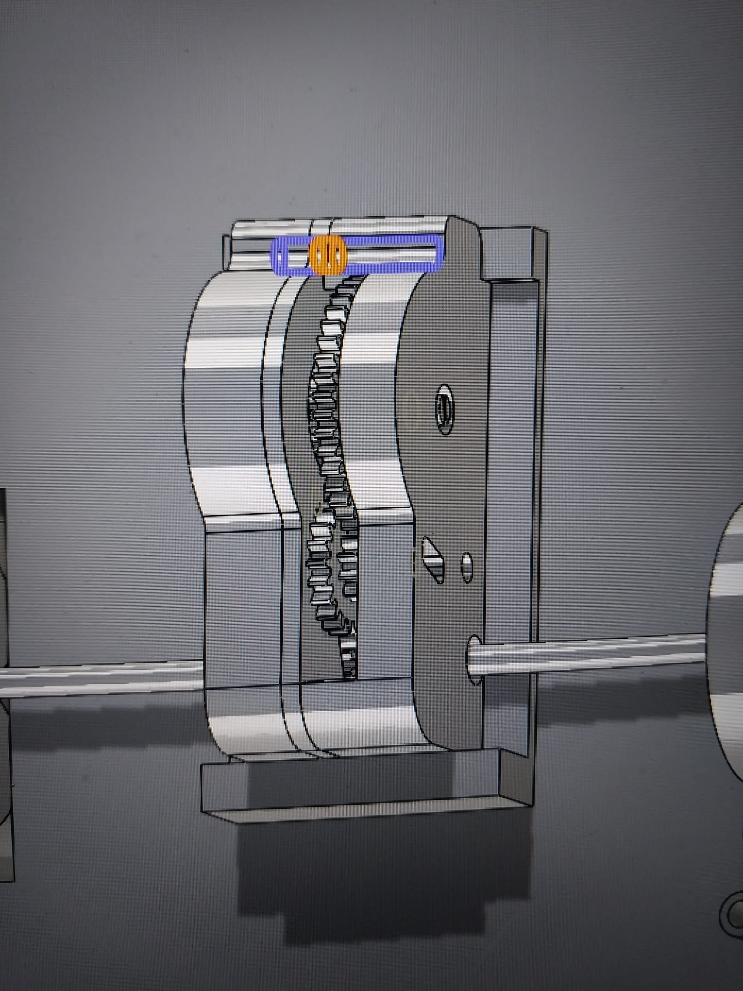

10) Concentric mate between motor 1 and motor 2: the left lower hole of motor 1 is concentric with the left lower hole of motor 2.

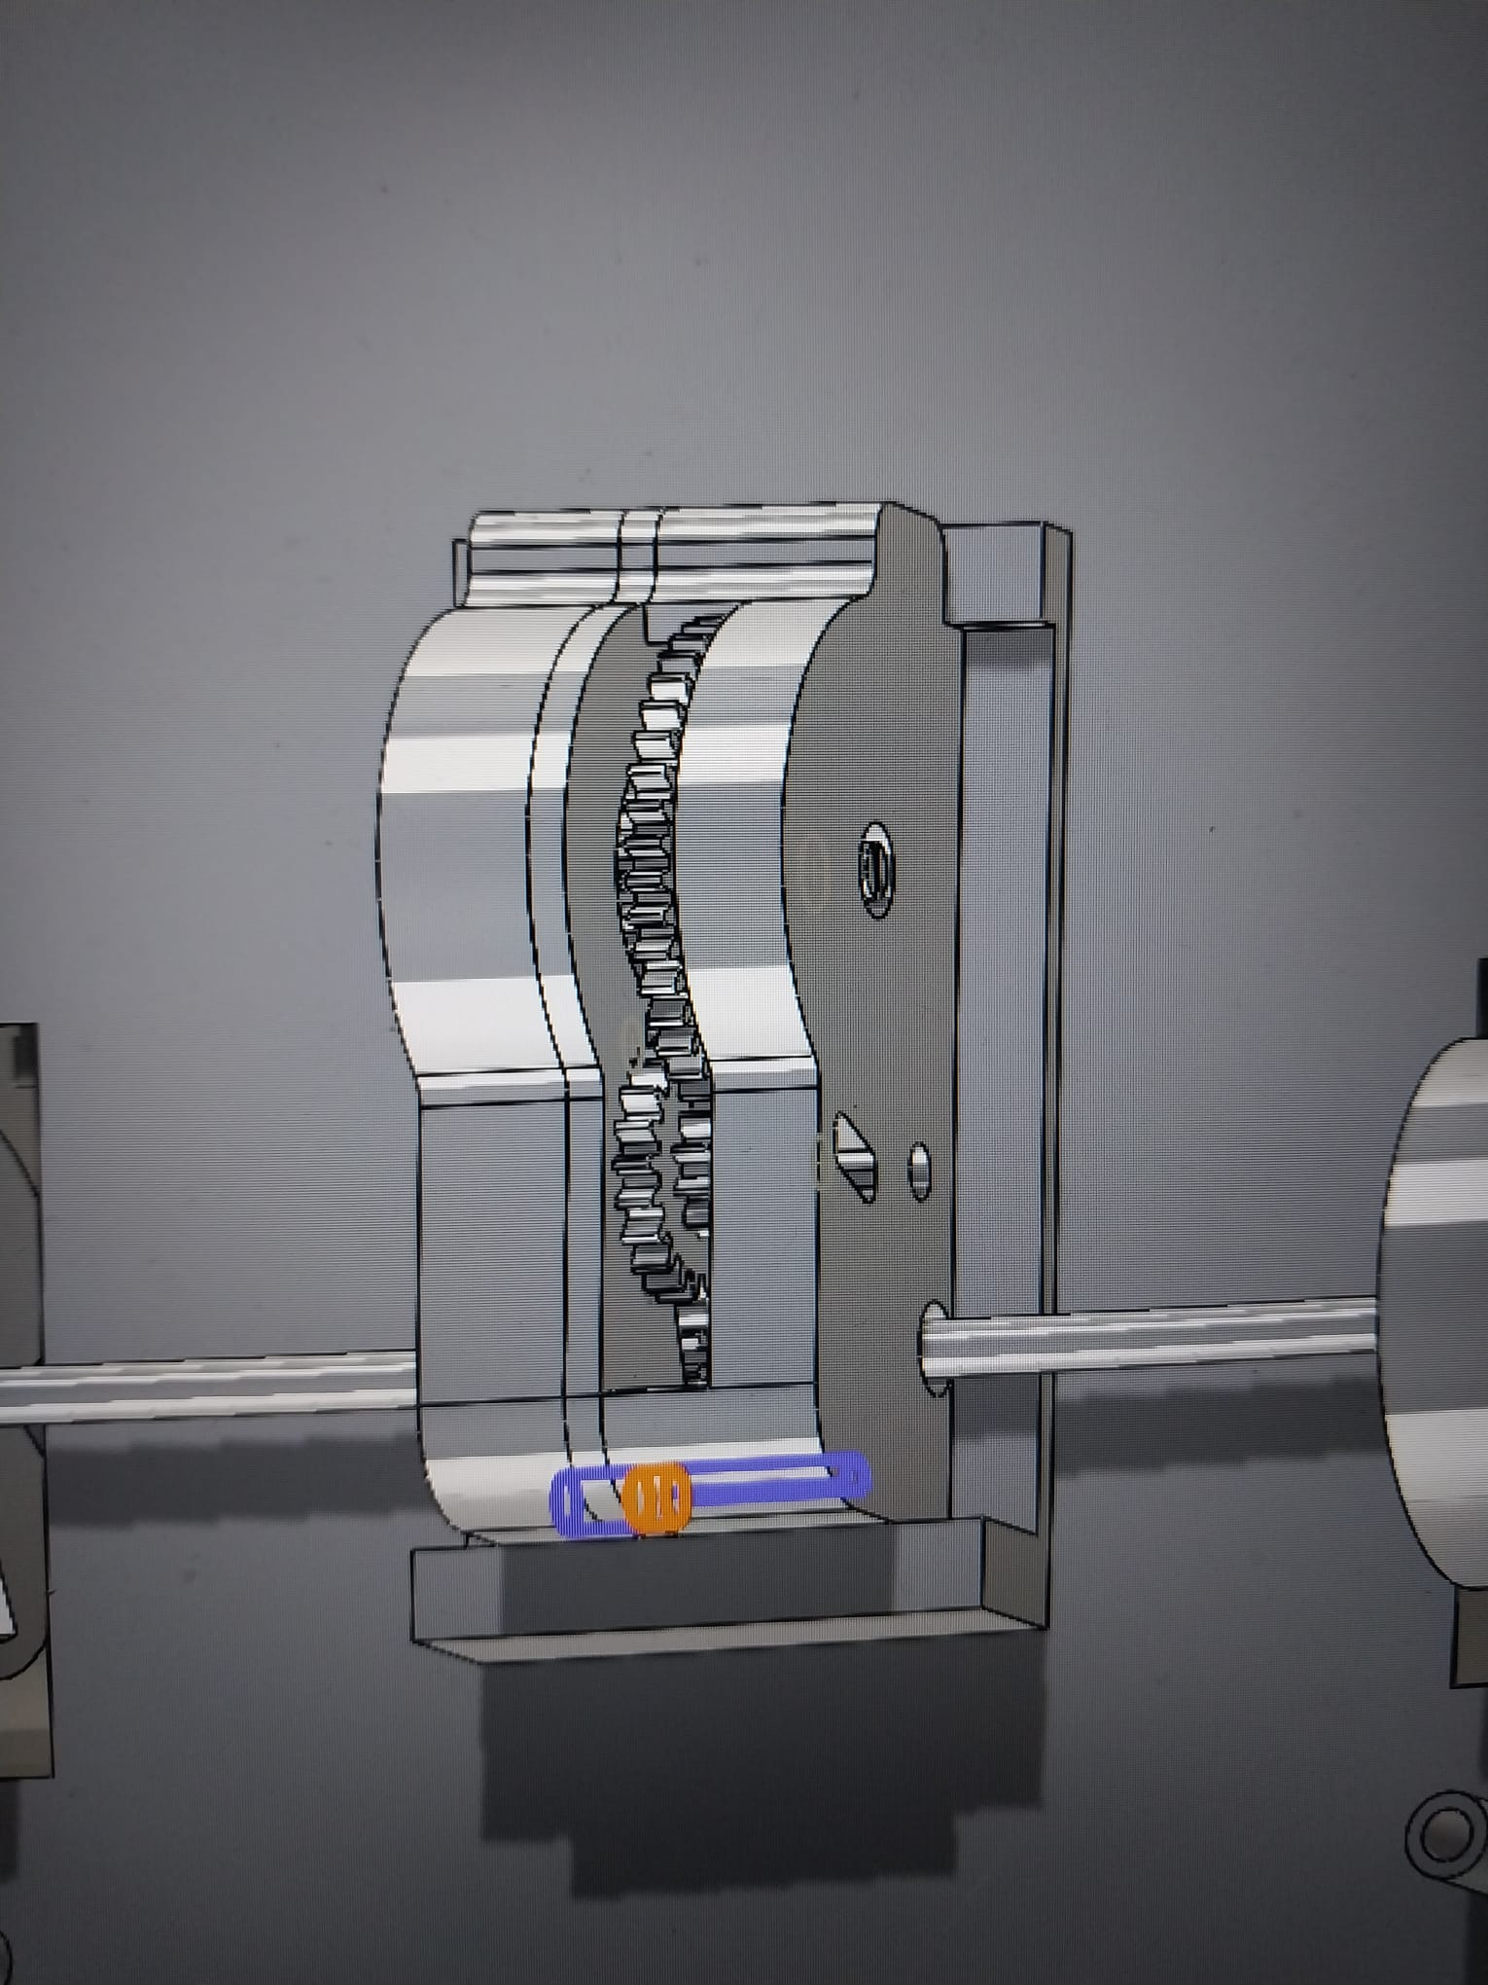

11) Coincide mate between motor 1 and motor 2: the inner face of motor 1 coincides with the outer face of motor 2.

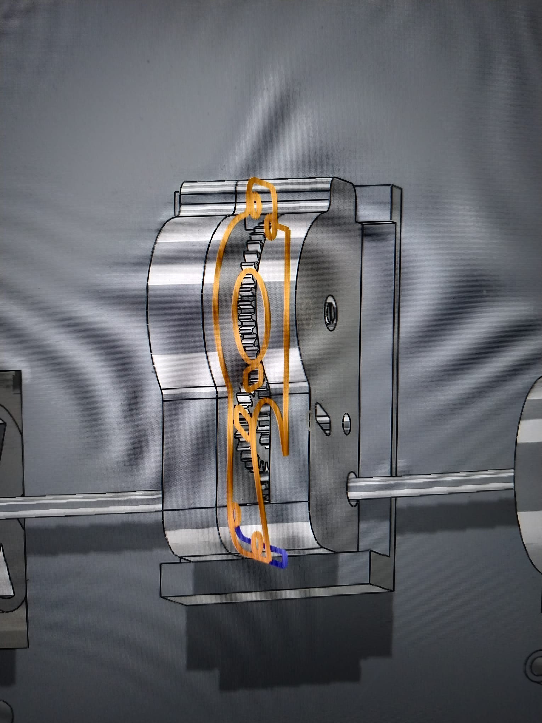

12) Concentric mate between the upper part and lower body: the left upper cylinder part of the motor lower body is concentric with the upper body.

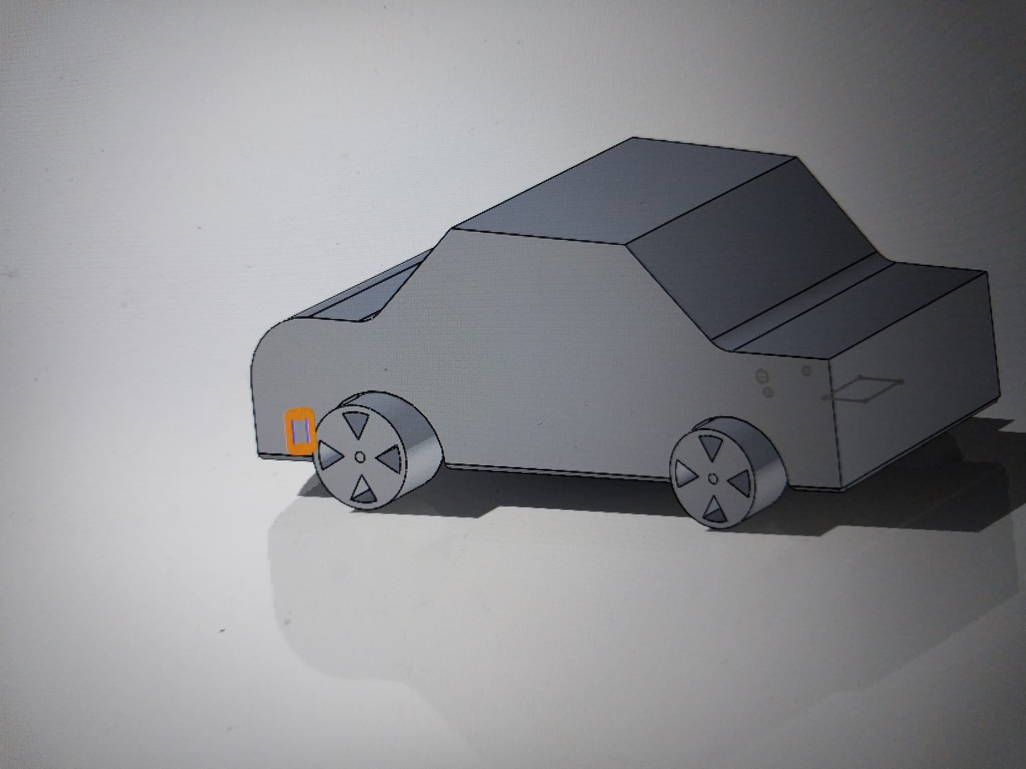

13) Concentric mate between the upper part and lower body: the left lower cylinder part of the motor lower body is concentric with the upper body.

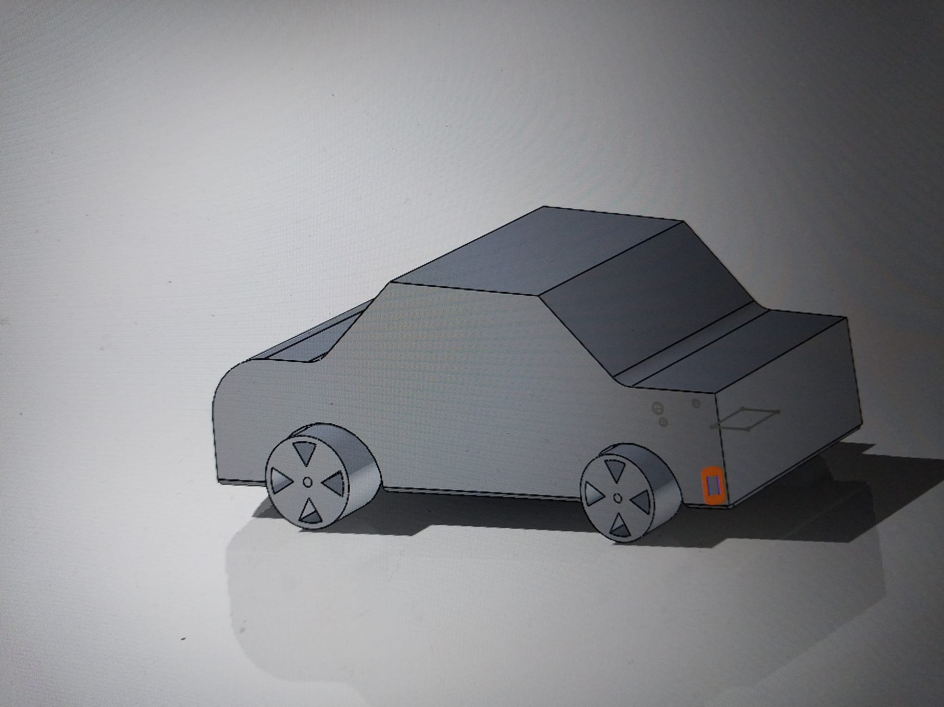

14) Concentric mate between shaft and wheel: the shaft is concentric with the middle cylinder of the right back wheel.

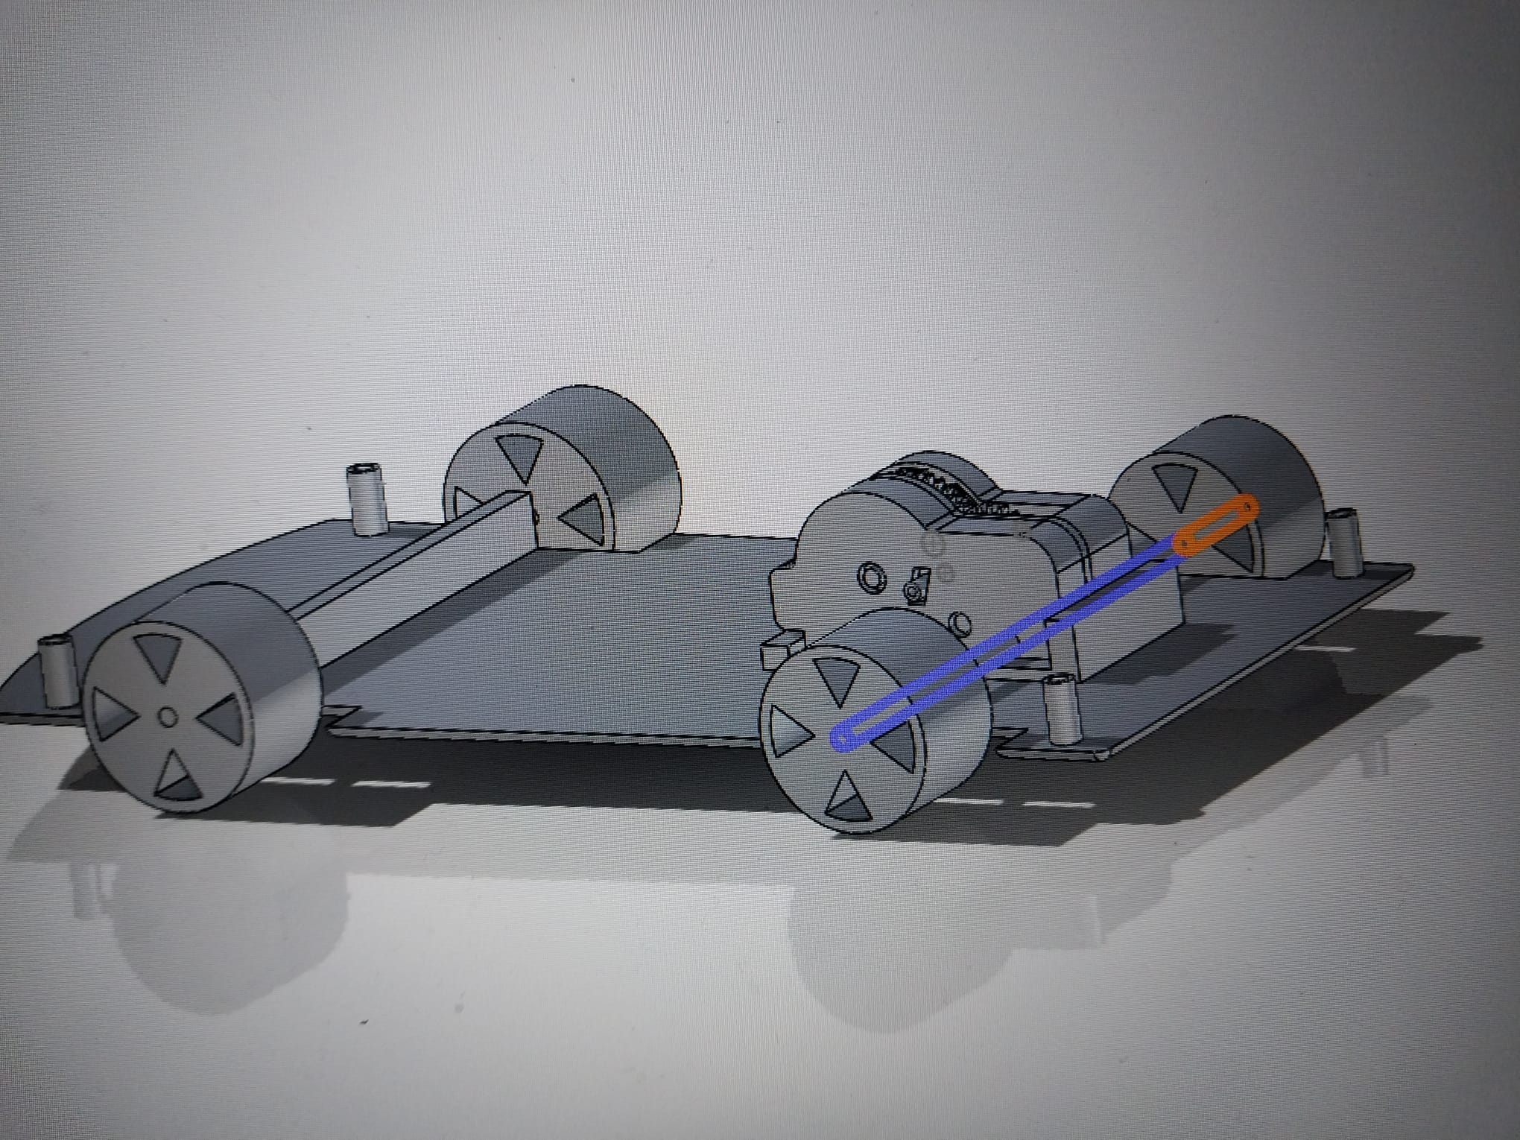

15) Coincide mate between shaft and wheel: the shaft coincides with the outer side of the right back wheel.

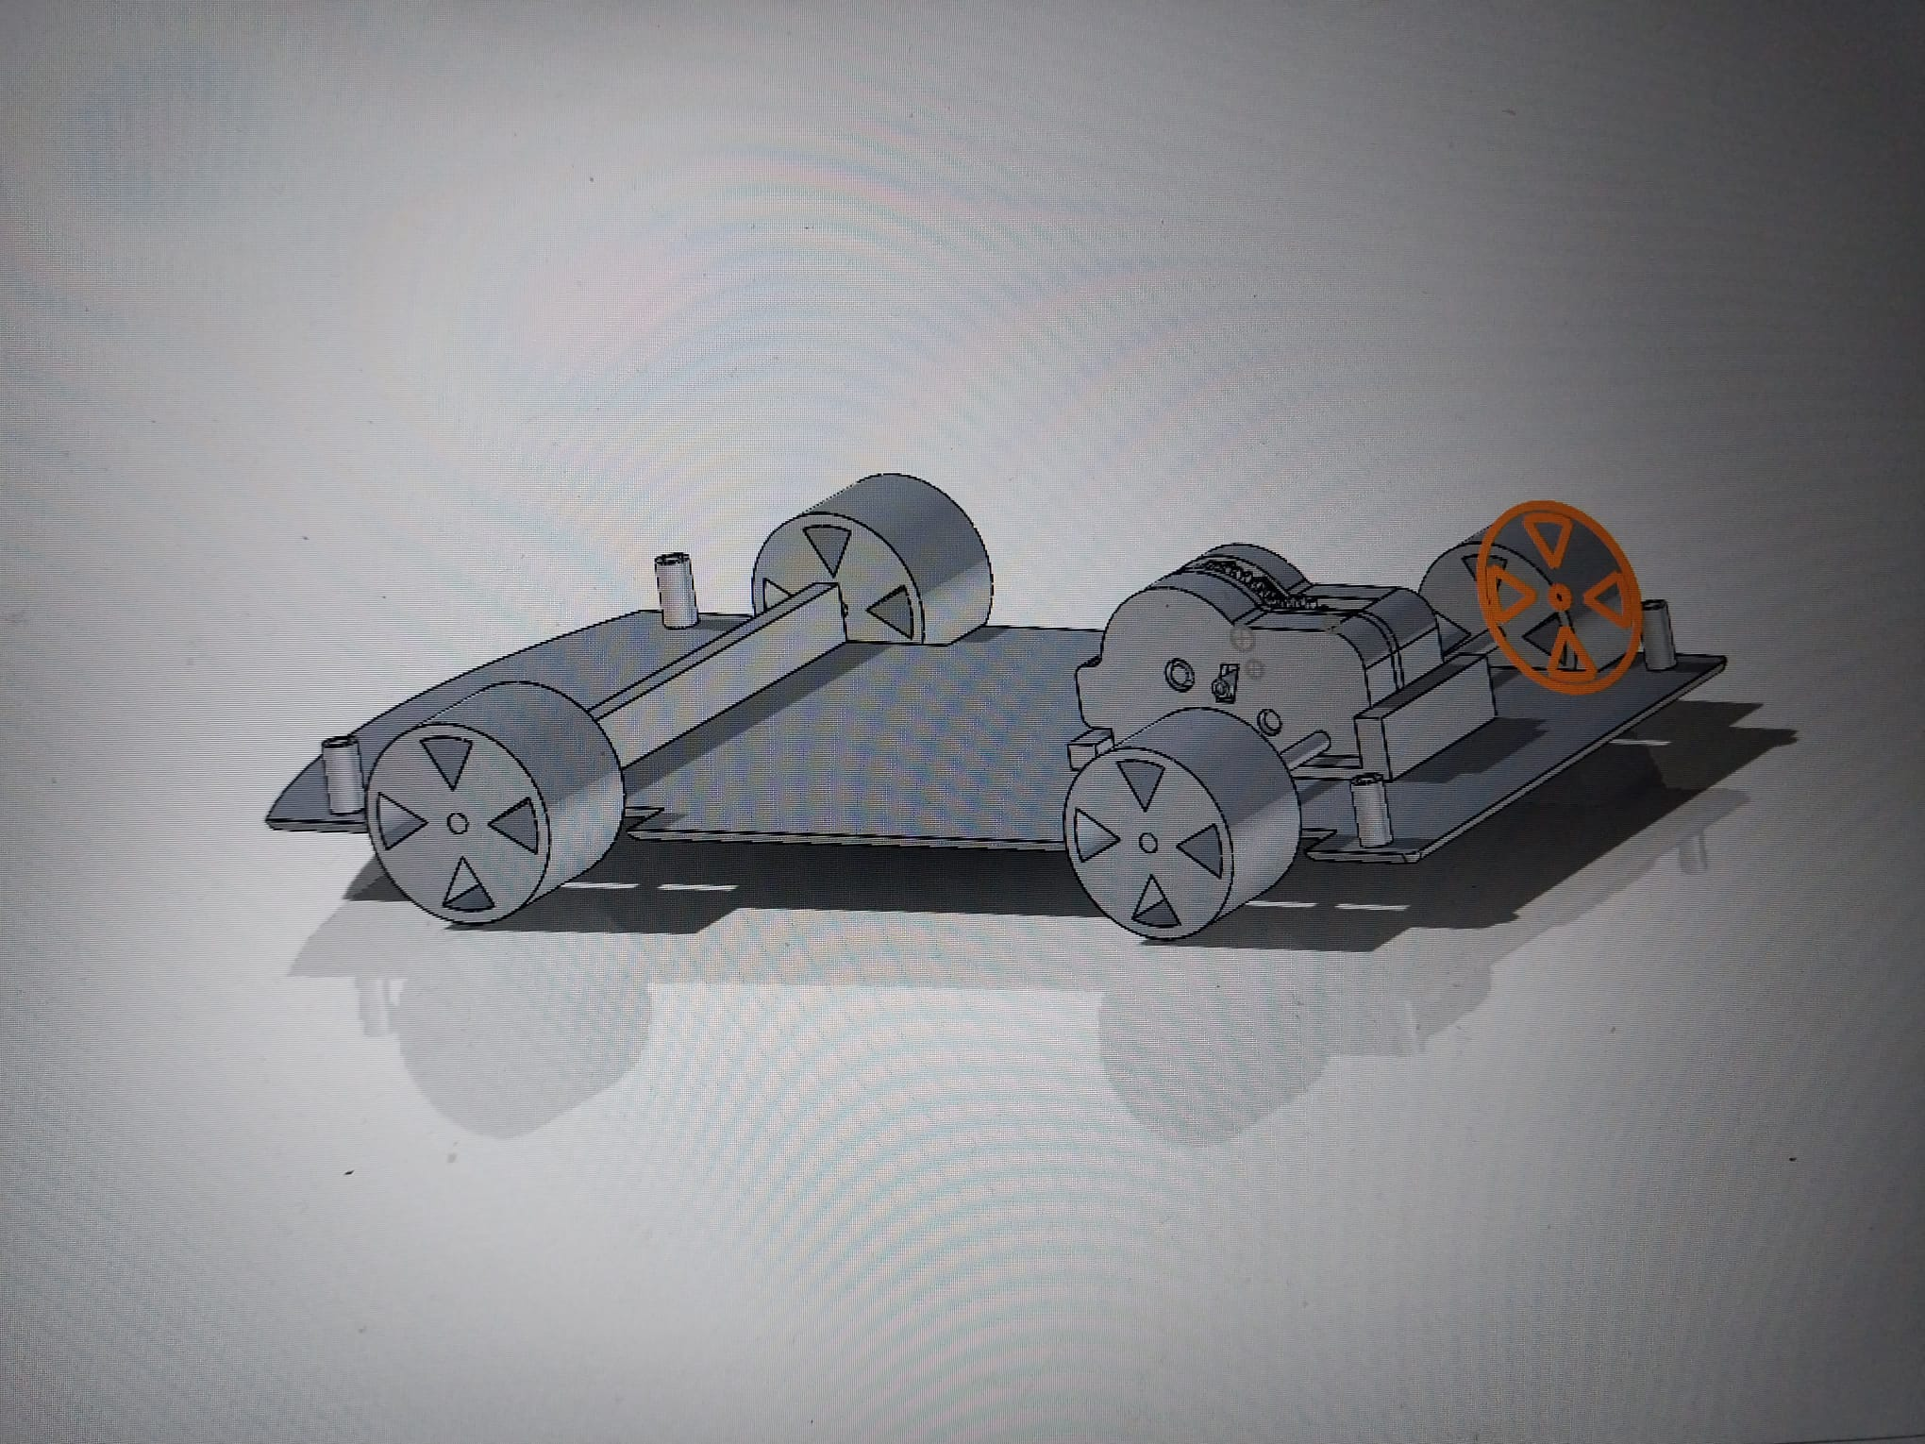

**Design:**

In this section, 2D technical drawings of each component and also the assembly is given below. Dimensions with the standard views of the gears, motors as well as wheel and the body parts are provided.

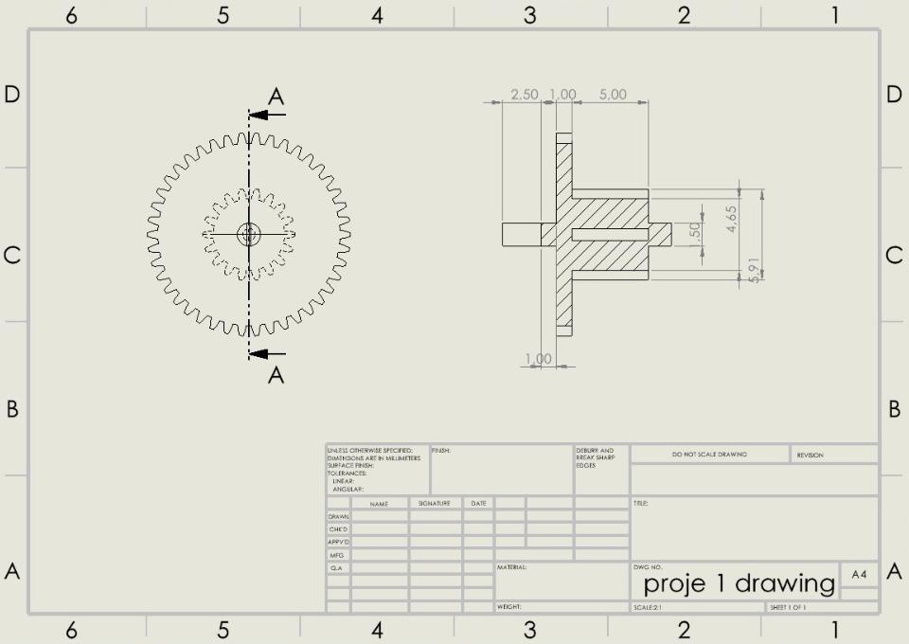

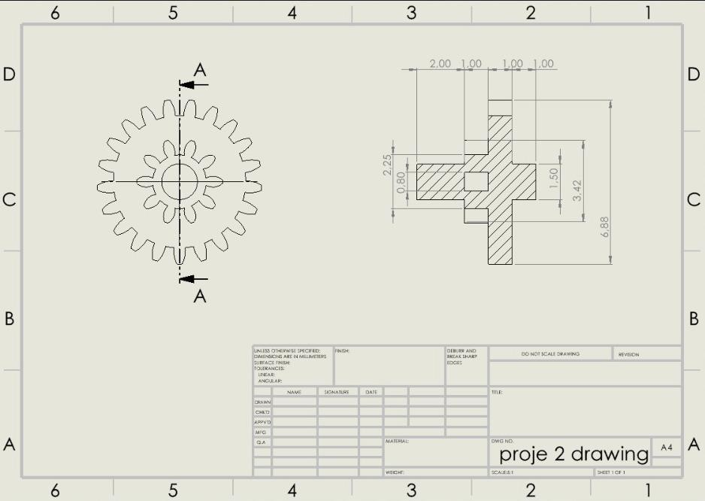

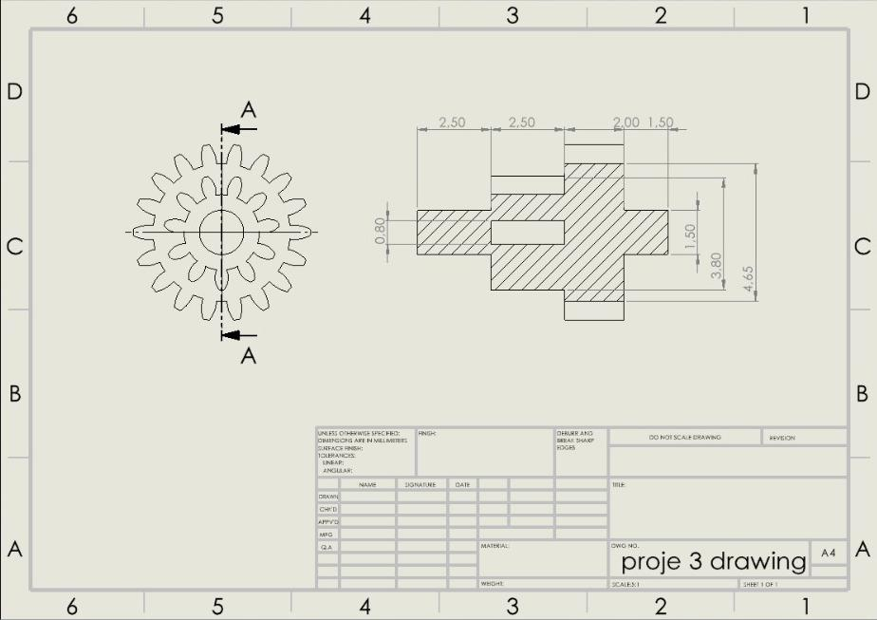

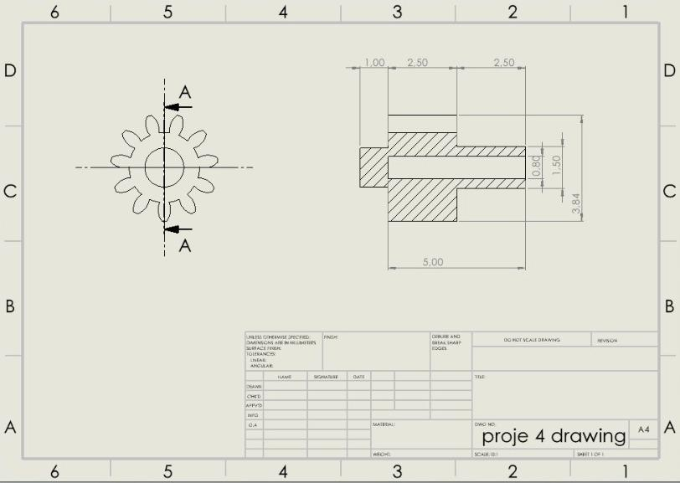

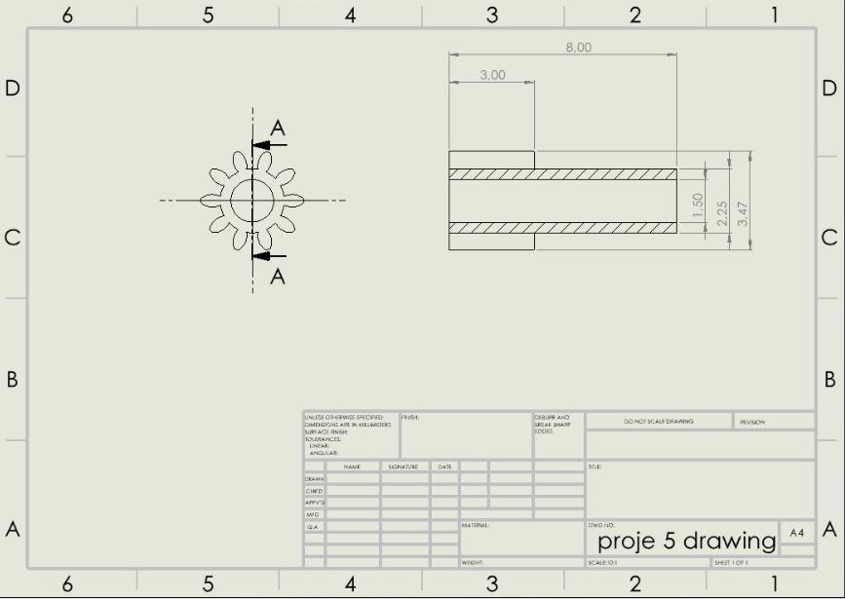

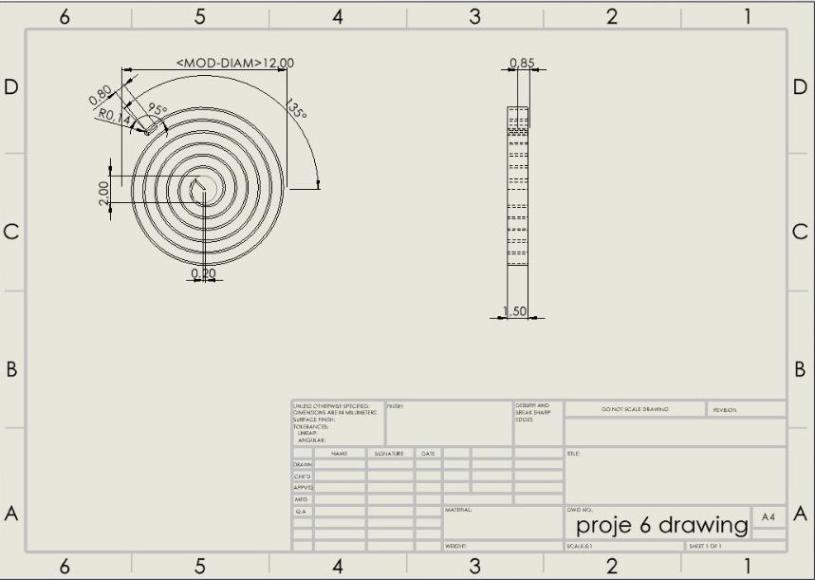

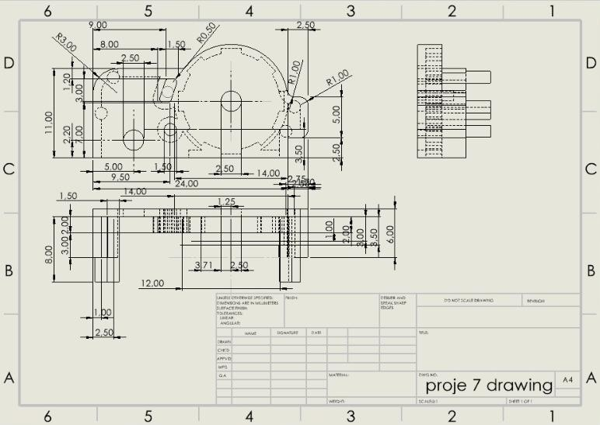

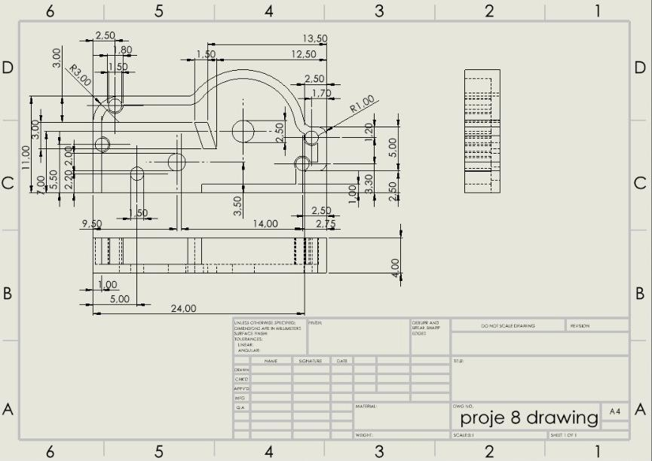

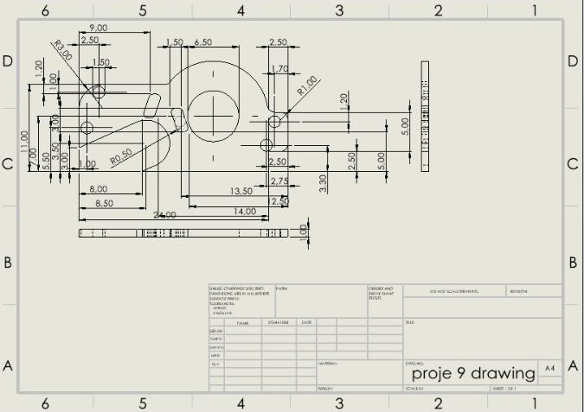

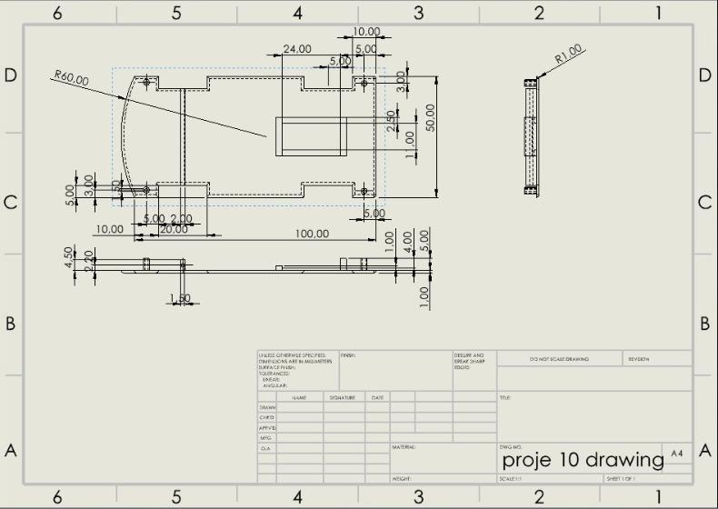

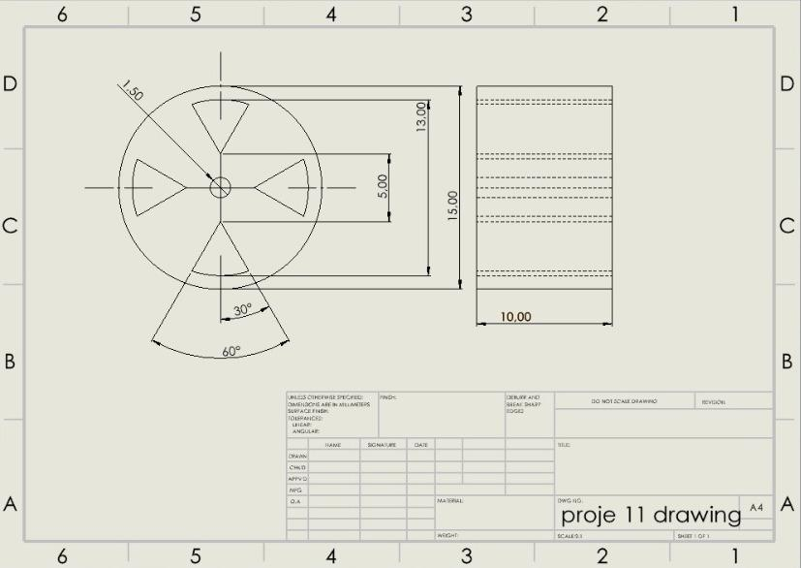

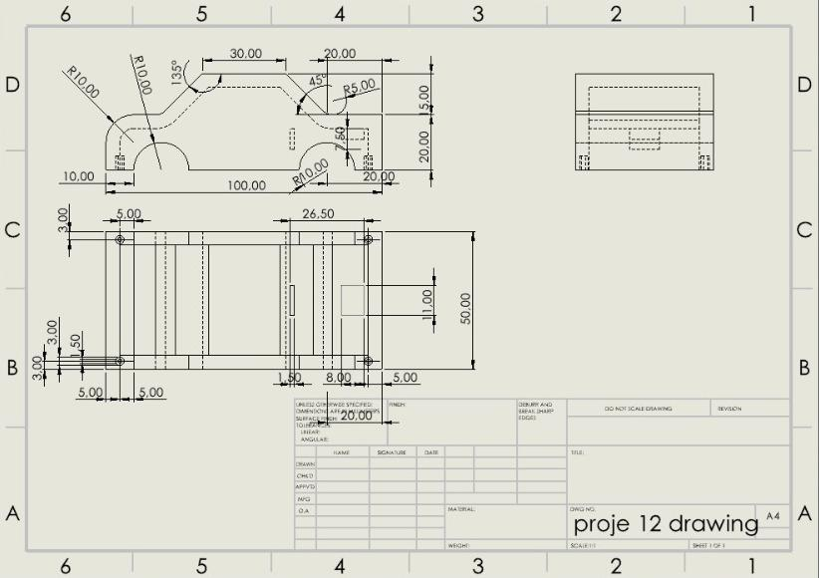

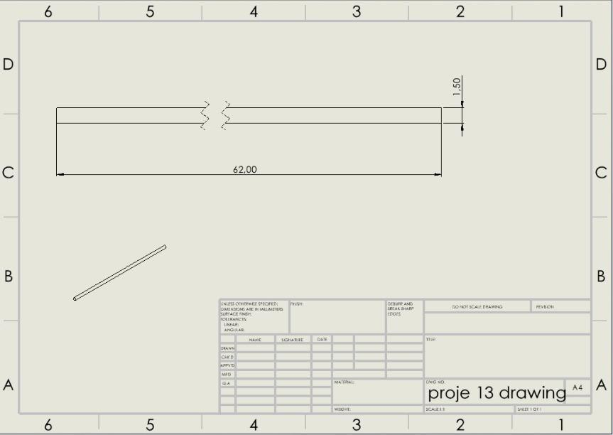

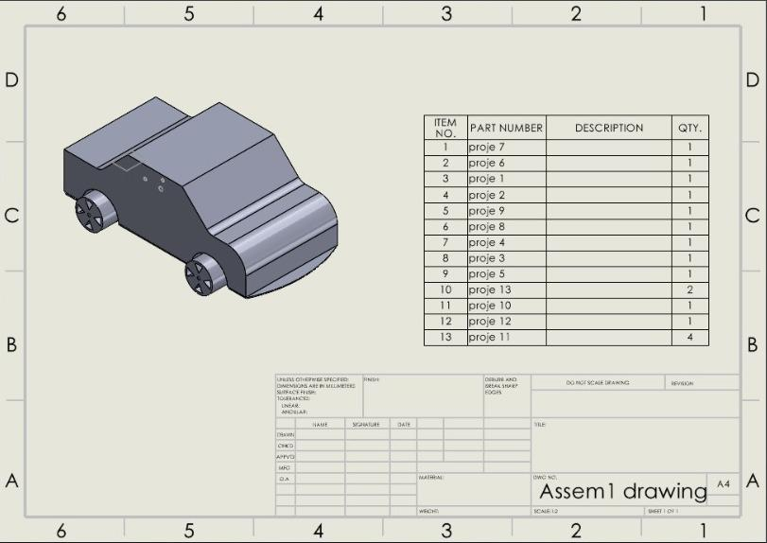

**Motion Study:**

Motion study of the project is provided in the attached solidworks file.

**Suggestions/ Improvements:**

We can add windows and mirrors to make the product look more aesthetic. Also, we can increase the number of coiled springs and it makes the car stronger. Finally, we can use rubber instead of PLA but it will increase the cost of the car.

**References & Resources:**

DG Enterprise and Industry (2013), Study on the competitiveness of the toy industry, ECSIP consortium.

Shirbon, E. (2009, August 14). *Da vinci's lion prowls again after 500 Years*. Reuters. Retrieved December 4, 2022, from <https://www.reuters.com/article/us-france-davinci-lion/da-vincis-lion-prowls-again-after-500-years-idUSTRE57D1MQ20090814>

Sorrel, C. (2011, April 11). *It's a wind up: Gorgeous Spring-powered toy car not for kids*. Wired. Retrieved December 4, 2022, from <https://www.wired.com/2011/04/its-a-wind-up-gorgeous-spring-powered-toy-car-not-for-kids/>

Wulffson, D. (n.d.). *One more step*. archive.ph. Retrieved December 4, 2022, from https://archive.md/20121209181102/http://webcache.googleusercontent.com/search#selection-33.0-47.1

<https://www.statista.com/statistics/247415/toy-sales-in-the-us-toy-vehicles/>

<https://www.alliedmarketresearch.com/toy-cars-market-A15020>

DG Enterprise and Industry (2013), Study on the competitiveness of the toy industry, ECSIP consortium.

<https://archive.md/20121209181102/http://webcache.googleusercontent.com/search?q=cache:zCaydYvRE2oJ:accelerateu.org/assessments/ELA6/WindupToys.doc+How+do+Wind+up+toys+work&hl=en&ct=clnk&cd=1&gl=us>

<https://www.reuters.com/article/us-france-davinci-lion/da-vincis-lion-prowls-again-after-500-years-idUSTRE57D1MQ20090814>

<https://www.wired.com/2011/04/its-a-wind-up-gorgeous-spring-powered-toy-car-not-for-kids/>